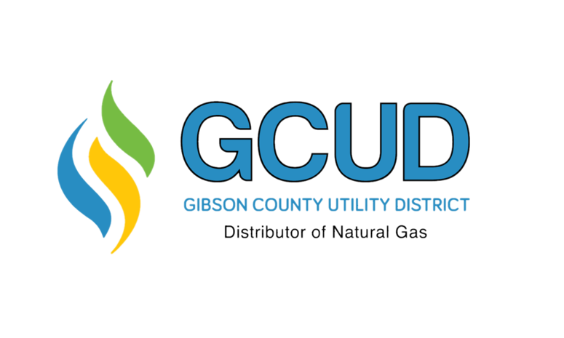

1300 N. Hwy 45 Bypass
PO Box 350
Trenton, TN 38382
Phone: (731) 855-1441
GibsonCountyGas.com

Dear Customer,

You are receiving this notice because our records indicate that you may have a buried natural gas line that runs from your gas meter to a structure or gas appliance on your property.
As your natural gas provider, Gibson County Utility District is committed to the safe operation of our system. We are required by federal regulations to inform you about the proper care and responsibilities associated with customer-owned gas piping.

Important Responsibility Information
Gibson County Utility District is responsible for maintaining the natural gas system up to the meter. However, all piping located downstream (on the customer side) of the meter is the property and responsibility of the homeowner or property owner. This includes any buried gas lines extending to buildings, equipment, or appliances.
Because these lines are not owned or maintained by the utility, it is important that you take appropriate steps to ensure their safe operation.

Recommended Safety Practices
To help protect your property and ensure safety, we recommend the following:
- Inspect buried gas piping periodically for leaks or damage.
- Check for corrosion if your piping is metallic.
- Repair unsafe conditions promptly or have the gas supply shut off until repairs are completed.
- Contact a qualified professional if you suspect a leak or damage.

Before You Dig – Call 811
If you plan to dig anywhere on your property, it is critical that you take the following steps:
- Call 811 (Tennessee One Call) before you dig. This is required by law.
- Notify 811 at least three (3) days in advance so utility-owned lines can be properly located.
- Dig carefully by hand near marked lines to avoid damaging underground facilities.
Failure to follow these steps can result in serious injury, service interruption, or costly repairs.

Questions or Assistance
This notice is provided for your safety and awareness. If you have any questions or need additional information, please contact our office.

Thank you for allowing us to serve you!
Gibson County Utility District

